|  |
| --- |
| **Republic of Kazakhstan**  **Ministry of Science and Higher Education**  **Astana IT University**  **Social Network**  **Profession: Software Engineering**  Completed by: Sabyrov T, Khozhimuratov M, Agadil N.  Checked by: Alshynov S.  **Astana, 2024** |

**Content**

|  |  |
| --- | --- |
|  | Page numbers |
| **Project Relevance** | 3 |
| **Analysis of competitors and similar projects** | 4 |
| **Target Audience** | 5 |
| **Features** | 6 |

**Project Relevance**

Social networking has evolved from a concept deeply rooted in human communication and interaction to a phenomenon shaping the digital landscape of the 21st century. Dating back to the early days of the internet, pioneers like SixDegrees, launched in 1997, laid the groundwork for what would eventually become the sprawling networks we know today. These platforms were rudimentary in comparison to their modern counterparts, yet they served as precursors, demonstrating humanity's innate desire for connectivity and community in the digital realm.

Today, social networking has permeated nearly every aspect of daily life, with billions of users worldwide relying on platforms like Twitter, Instagram, and LinkedIn to stay informed, entertained, and connected. The need for a social network project remains as relevant as ever, as users seek platforms that offer not only connectivity but also security, privacy, and meaningful engagement.(<https://datareportal.com/reports/digital-2024-kazakhstan#:~:text=For%20clarity%2C%20Kepios%20analysis%20shows,and%20the%20beginning%20of%202024.>). “For clarity, Kepios analysis shows that social media users in Kazakhstan increased by 3.7 million (+34.9 percent) between early 2023 and the beginning of 2024.”

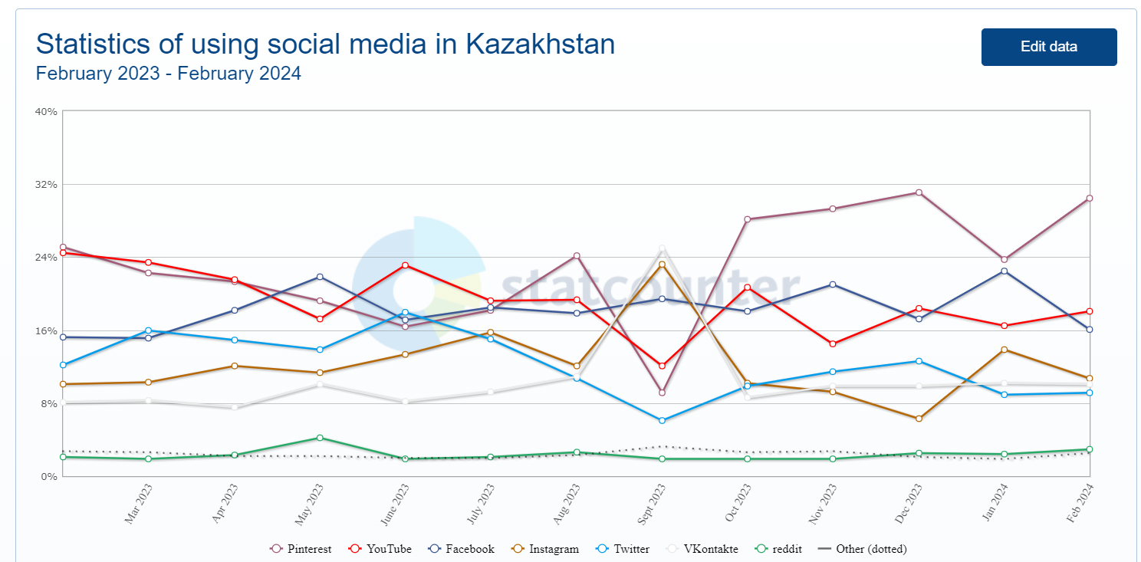

(<https://gs-statcounter-com.translate.goog/social-media-stats/all/kazakhstan?_x_tr_sl=en&_x_tr_tl=ru&_x_tr_hl=ru&_x_tr_pto=sc>)

In a world where human connection is increasingly mediated by technology, our project endeavors to bridge the gap between the virtual and the real, empowering users to form authentic relationships, share experiences, and build communities that transcend the limitations of physical space. Through thoughtful design, advanced features, and a commitment to user privacy and security, we aspire to create a social networking experience that not only meets but exceeds the expectations of our global audience.

**Analysis of competitors and similar projects**

There are few social media startups in Kazakhstan. One of the most popular is social media. As can be seen from the screenshot, the website has a typical social media structure: navigation bar (includes different victorines, music, content, language system, login/registration, messenger and music), the main page with different actions: music and video and so on.

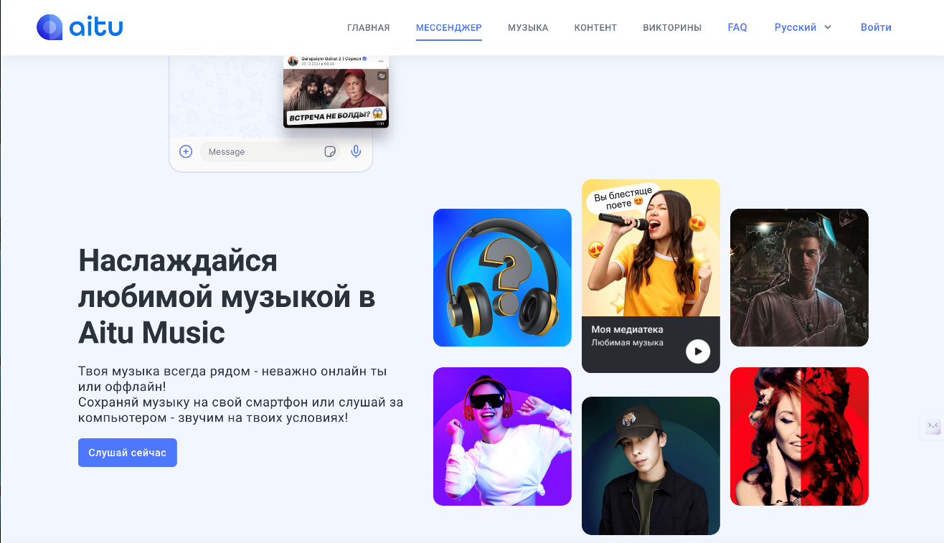

*https://aitu.io/*

**Advantages**:

Modern Design: Aitu's website has a modern and attractive design that is in line with current trends.

Mobile Optimization: Aitu's website is optimized for mobile devices, providing a seamless user experience on smartphones.

**Disadvantage:**

Missing Information. The Aitu website lacks information about some important aspects of the app, such as security and data privacy.

Unoptimized loading speed: The Aitu website may load slowly, especially on mobile devices. This could be due to too much content on the page, poor image and JavaScript optimization.

Also, our neighbor country with same mentality Russia has its own websites and actually they are in another level. So, as we have one history, same economics, mentality we can borrow from them advantages and experience. For example, VK, Telegram (founder from Russia), Mail, Odnoklassnniky.

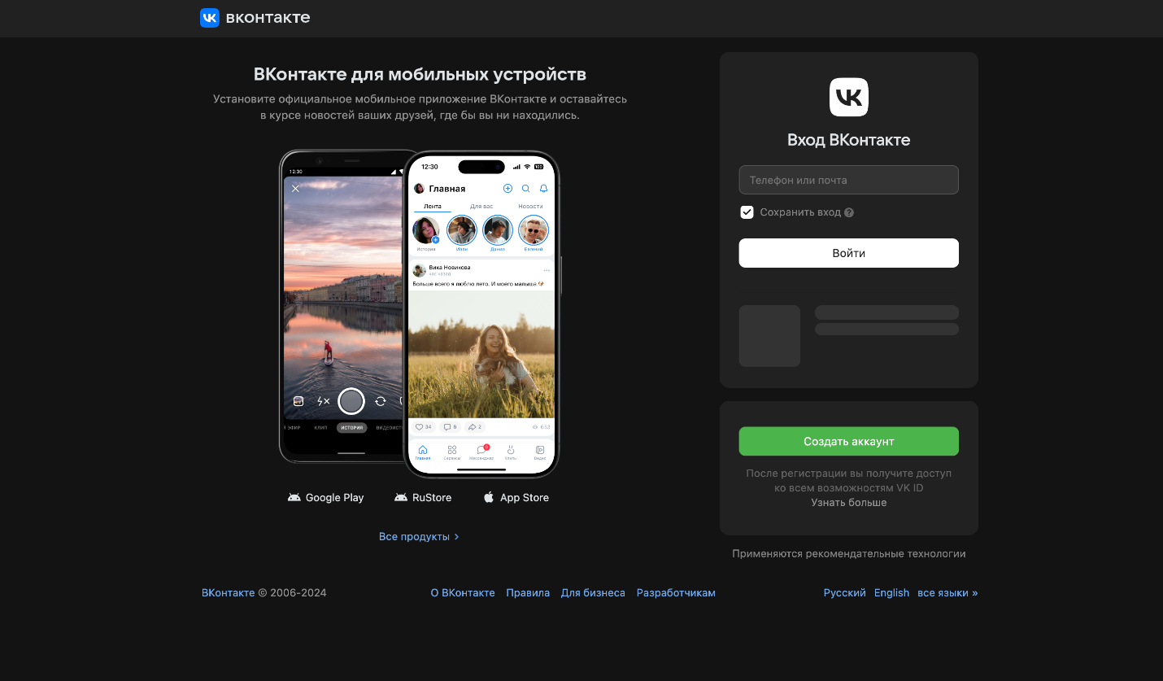*https://vk.com/*

This is a screenshot taken from the VK.

**Disadvantage**: you cannot use functions without signing in, there are own reels, tiktok system, but with bad quality.

**Advantage**: simple design, comfortable, many music, fast switch on 2nd account, big data of information, for example photos, music, videos and etc.

And now we would analysis the most popular social media. They are moslty from the USA. For example, Instagram, facebook, twitter (now x), and so on.

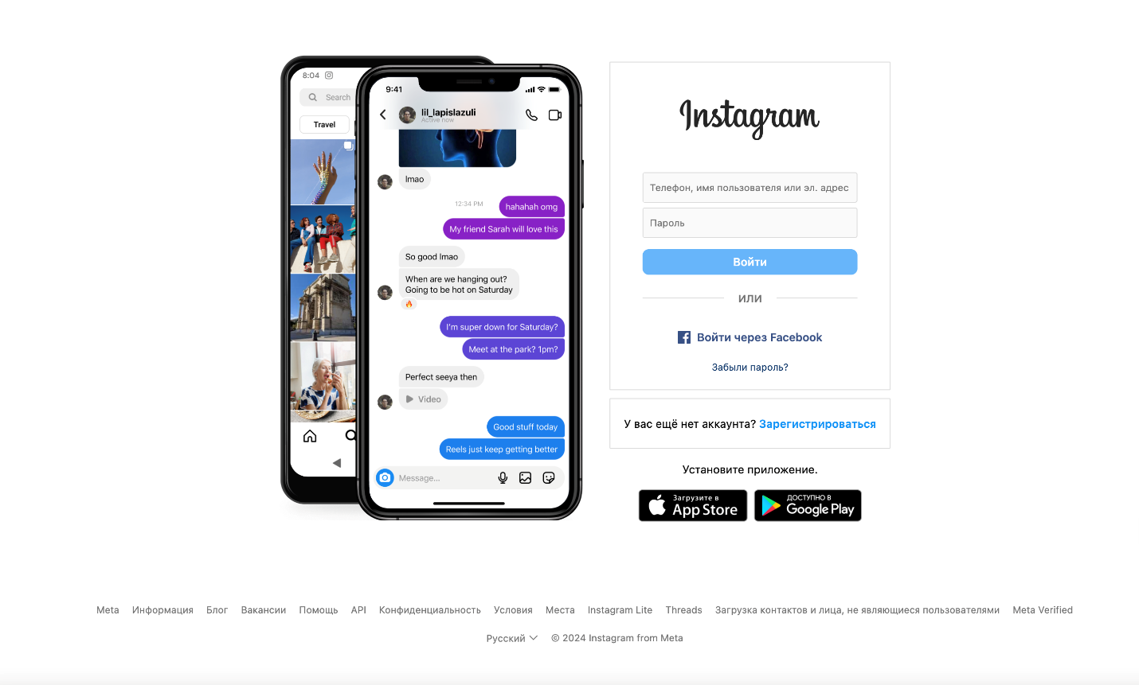*https://www.instagram.com/*

This is a screenshot taken from Instagram.

**Disadvantage**: you cannot use functions without signing in, not so many functions as in VK.

**Advantage**: simple design, comfortable reels system, world users, easy to popularize your business.

**Target audience**

Our project targets a diverse audience, but we place particular emphasis on teenagers and students, recognizing their significant presence and influence in the digital sphere. With our social network primed to resonate predominantly among students of Astana IT University, aged between 16 and 25, we aim to cater to their specific needs, interests, and preferences.

**Teenagers and Students:**

Within the age range of 16 to 25, teenagers and students form a vibrant and dynamic demographic segment. As digital natives, they possess a deep-seated familiarity with social media platforms and are avid consumers of online content. Our project seeks to capitalize on their tech-savvy nature and social connectivity by providing a tailored platform that caters to their academic, social, and recreational interests.

**Features and functions**

Some of the features and functionality of a GoLang project using the Fiber framework:

**CRUD functions for posts (Create, Read, Update, Delete):**

Functions for managing posts include creating (CreatePost), reading all posts (AllPost), reading detailed information about a post (DetailPost), updating a post (UpdatePost), and deleting a post (DeletePost).

**Subscribing and unsubscribing from users (Follow/Unfollow):**

The UniquePost function allows you to retrieve posts only from those users that the current user is following.

**Authentication and authorization (Login/Registration):**

Functionality for registering and authenticating users in a web application using Fiber, including validating and processing request data, creating a new user account, and generating and transmitting a JWT token for authenticated access to the application.

**Comments and their management:**

The new item includes functions for working with comments, although adding and deleting them can be implemented similarly to CRUD operations for posts. Functions include creating a comment (CreateComment), updating a comment (UpdateComment), deleting a comment (DeleteComment), and reading comments on a specific post (ReadComments).

**Uploading images:**

The imageController.go file implements a function for uploading images to the server.

**Using session cookies and JWT tokens:**

The project uses both session cookies and JWT tokens for user authentication and authorization.

**Scalability:**

The project is developed using the GoLang language and the Fiber framework, providing high performance and scalability to serve a large number of users.

These features provide basic functionality of the social network, including managing posts, comments, subscriptions, user authentication and authorization, and image uploading.